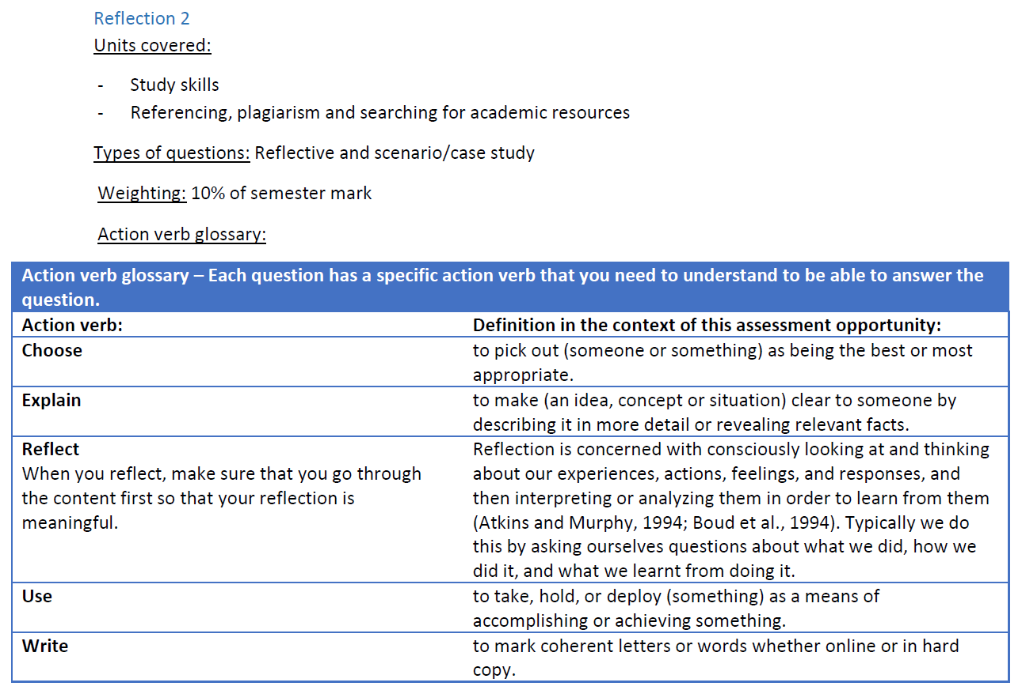

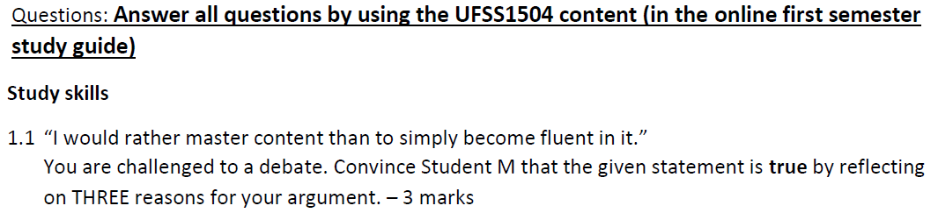

|  |
| --- |
| * When you master contexts it means you understand it in full details. * You can explain the contexts to the next person and make him understand. * Because it will be able to approach a test and pass. |

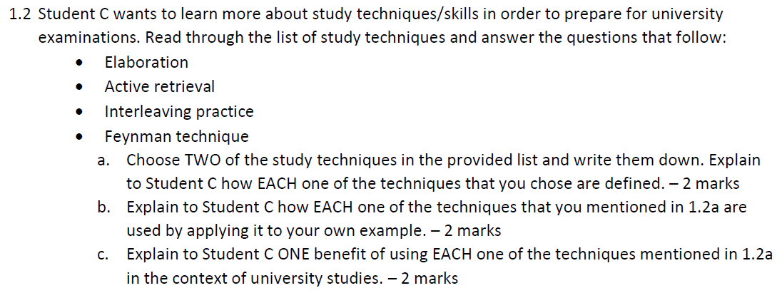

|  |
| --- |
| 1. Feynman technique – you write down something you studied in your own words, and then reflect with your textbooks.  * Active retrieval – it is the use of flashcards and writing practice tasks on your own to sharpen your knowledge. * Feynman technique – there are 4 steps you apply for you when you study to understand the concepts and be able to explain contexts in simpler terms. * Active retrieval – you do quizzes and you use flashcards to recall information. * Using Feynman you can master the concepts because most of the time you use your own words and also write down summarized notes * Using active retrieval you can recall all info because you tested yourself by doing quizzes and after you rectify mistakes you have done, so that when test comes you pass. |

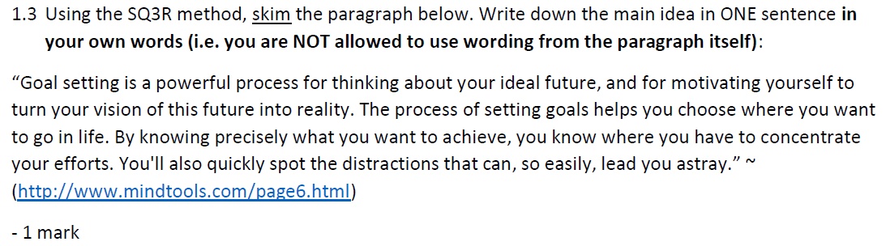

|  |
| --- |
| * Goal setting is paramount because it highlights what you need to do for your future and focus on it. On apex of that it encourages you to work towards your goal so that you can achieve it, you will be able to avoid distractions and do first things first. |

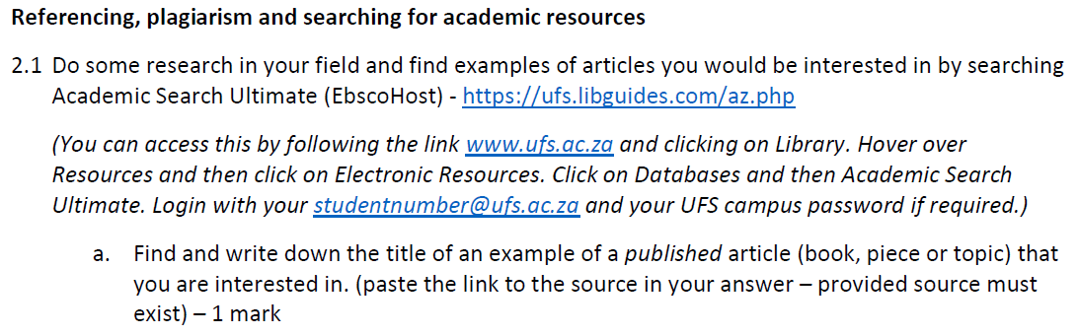

|  |
| --- |
| <https://eds-b-ebscohost-com.ufs.idm.oclc.org/eds/detail/detail?vid=1&sid=c15d78b3-032e-45ea-a09c-a81dc955efbb%40pdc-v-sessmgr03&bdata=JnNpdGU9ZWRzLWxpdmUmc2NvcGU9c2l0ZQ%3d%3d#db=asn&AN=148412968> |

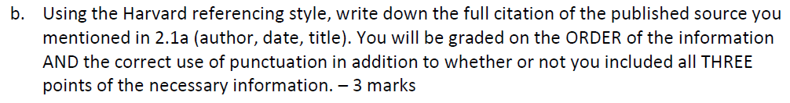

|  |
| --- |
| * Rymaszewska, Julia Ewa, Stanczykiewics, bartlomiej, Lion, Kataryzyna, Misiak, Blasej (Authors) * Published in 2020 * Title “ The impact of whole – body cryotherapy on lipid profile : A systematic review and meta – analysis “ . * Elsivier ( Publisher ) . |

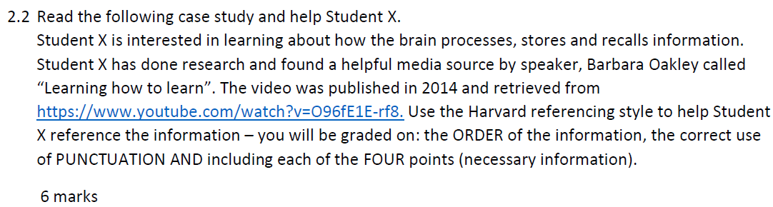

|  |
| --- |
|  |
| * https//www.youtube.com/watch?v=096fE1E-rf8 * Barbara Oakley ( The speaker ) * Title “ Learning how to learn “. * Publication of the video was in 2014 | |

